**Hadoop HDFS & MapReduce**

docker run command

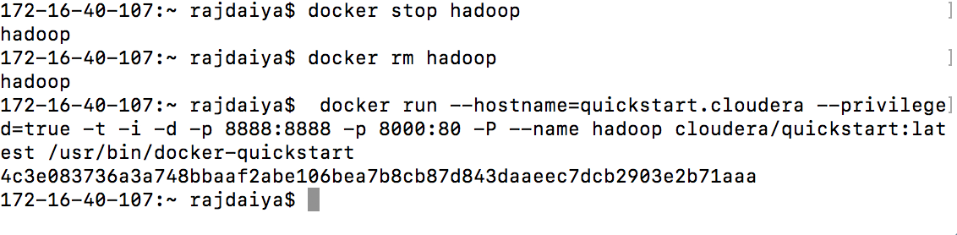

docker

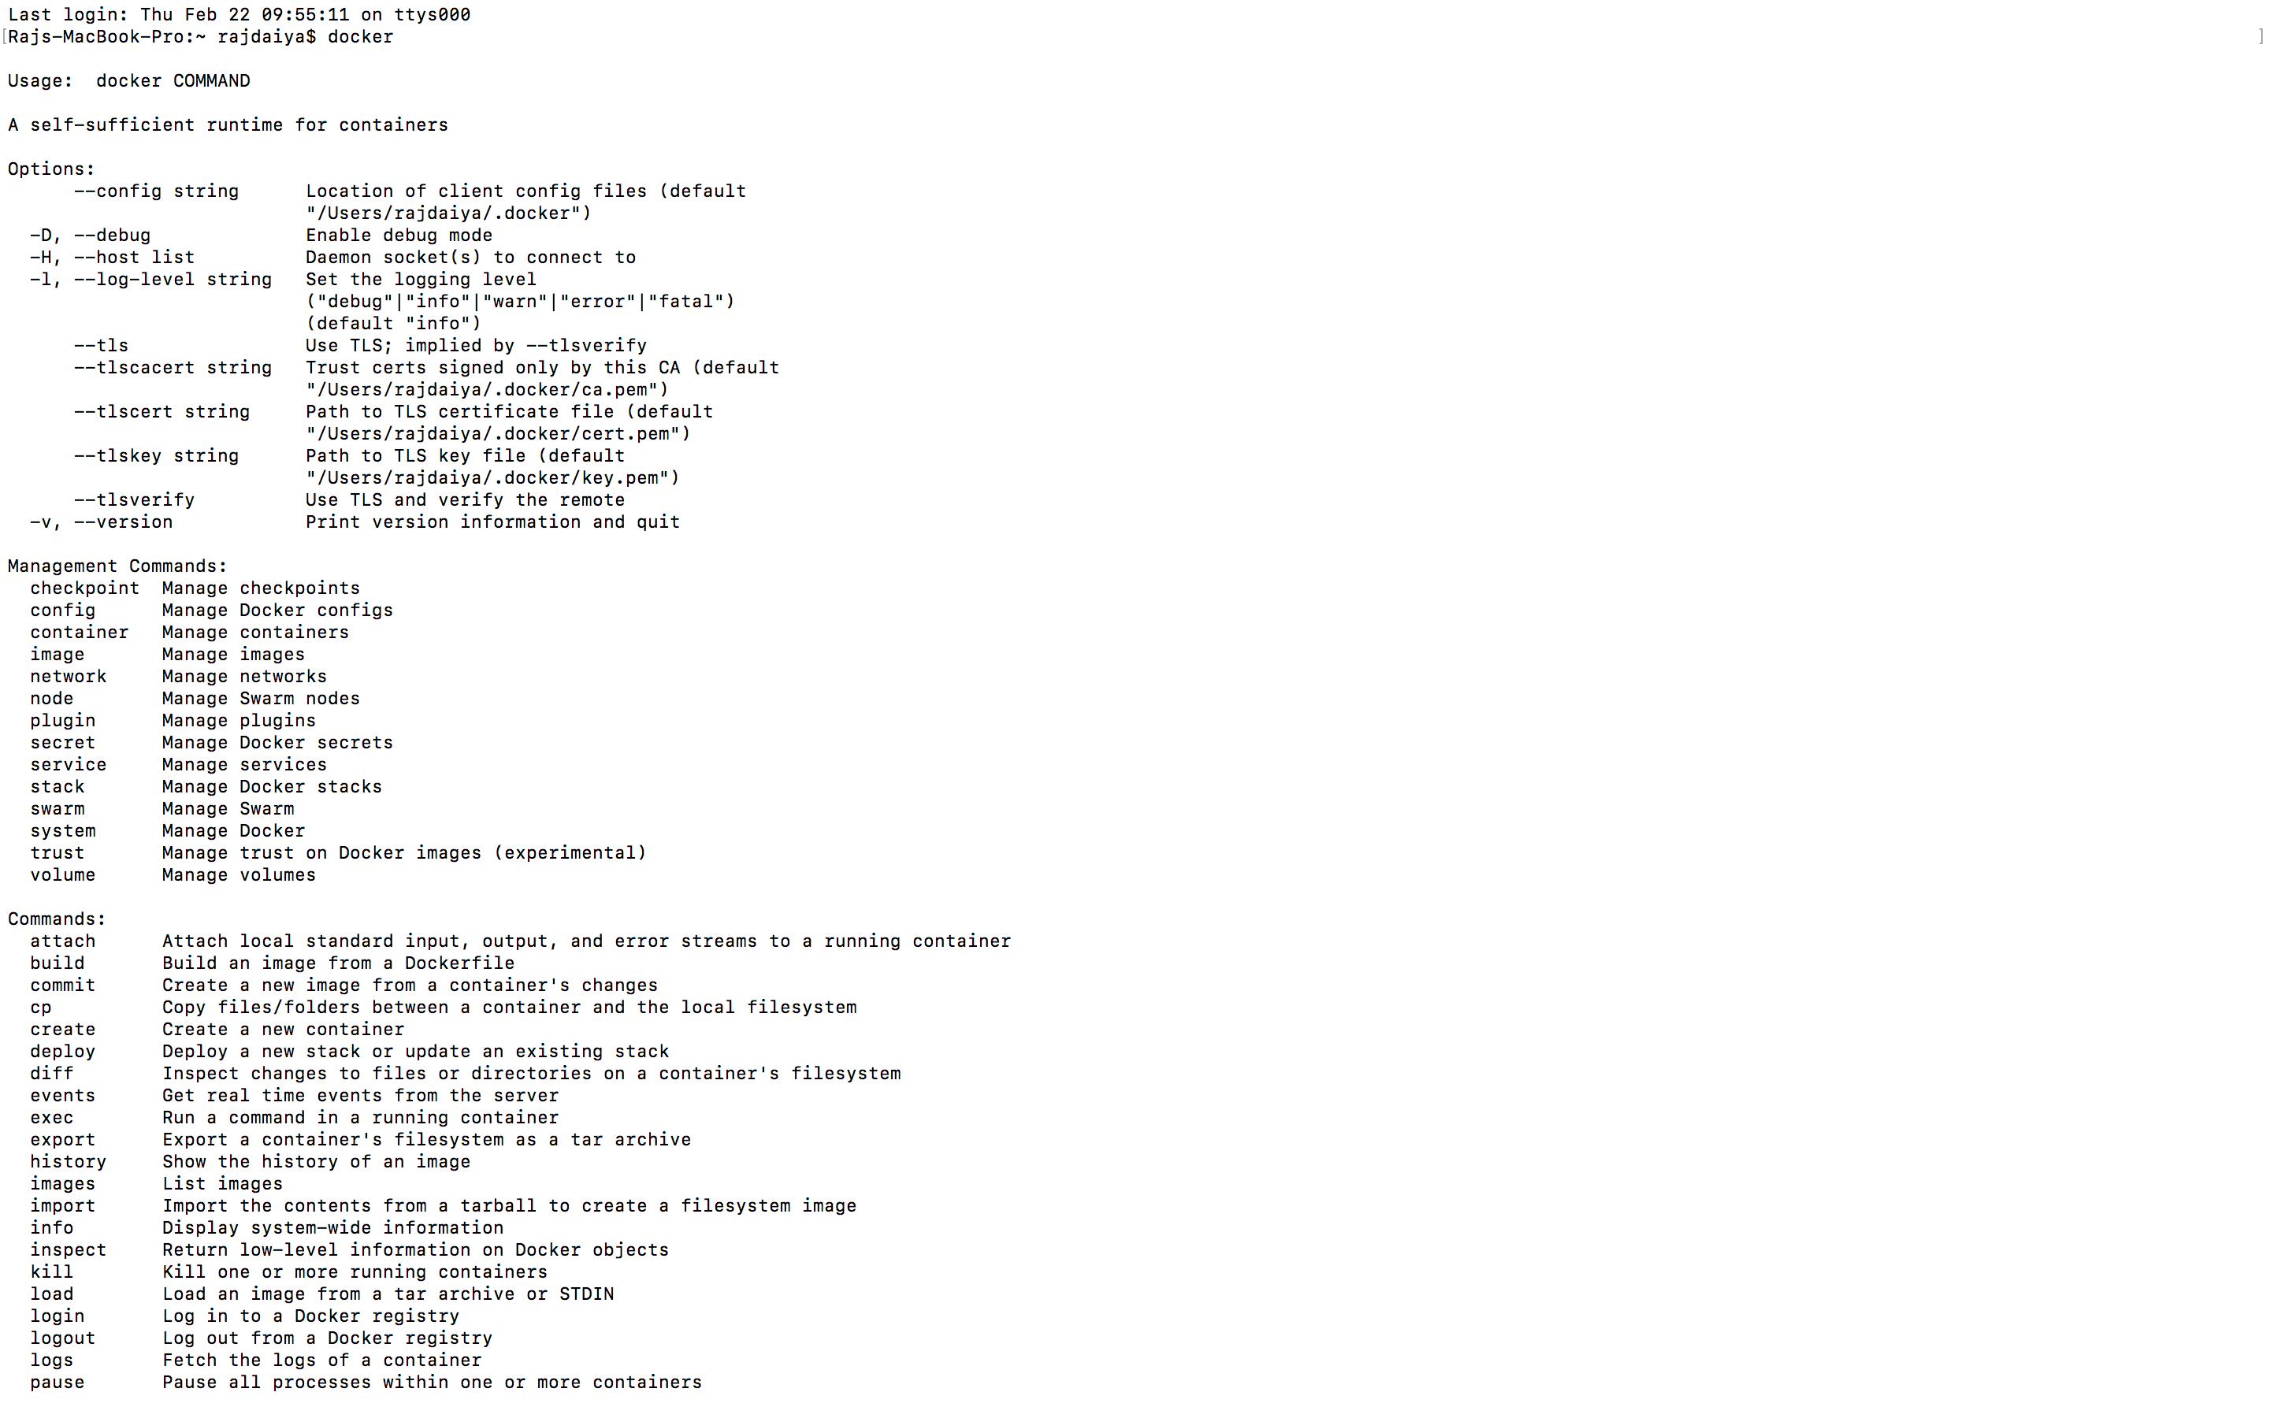

docker version command

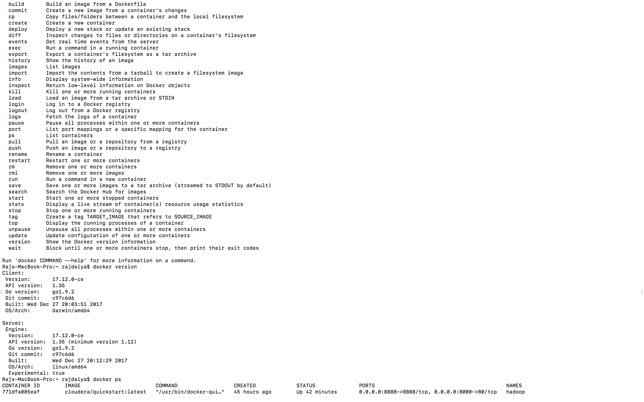

Running a version of Hadoop (docker or otherwise), create a directory on HDFS with your first name (e.g. mine will be ‘juan’). Submit a screen grab of the output of a Hadoop fs listing showing your home directory **and**your new directory in it

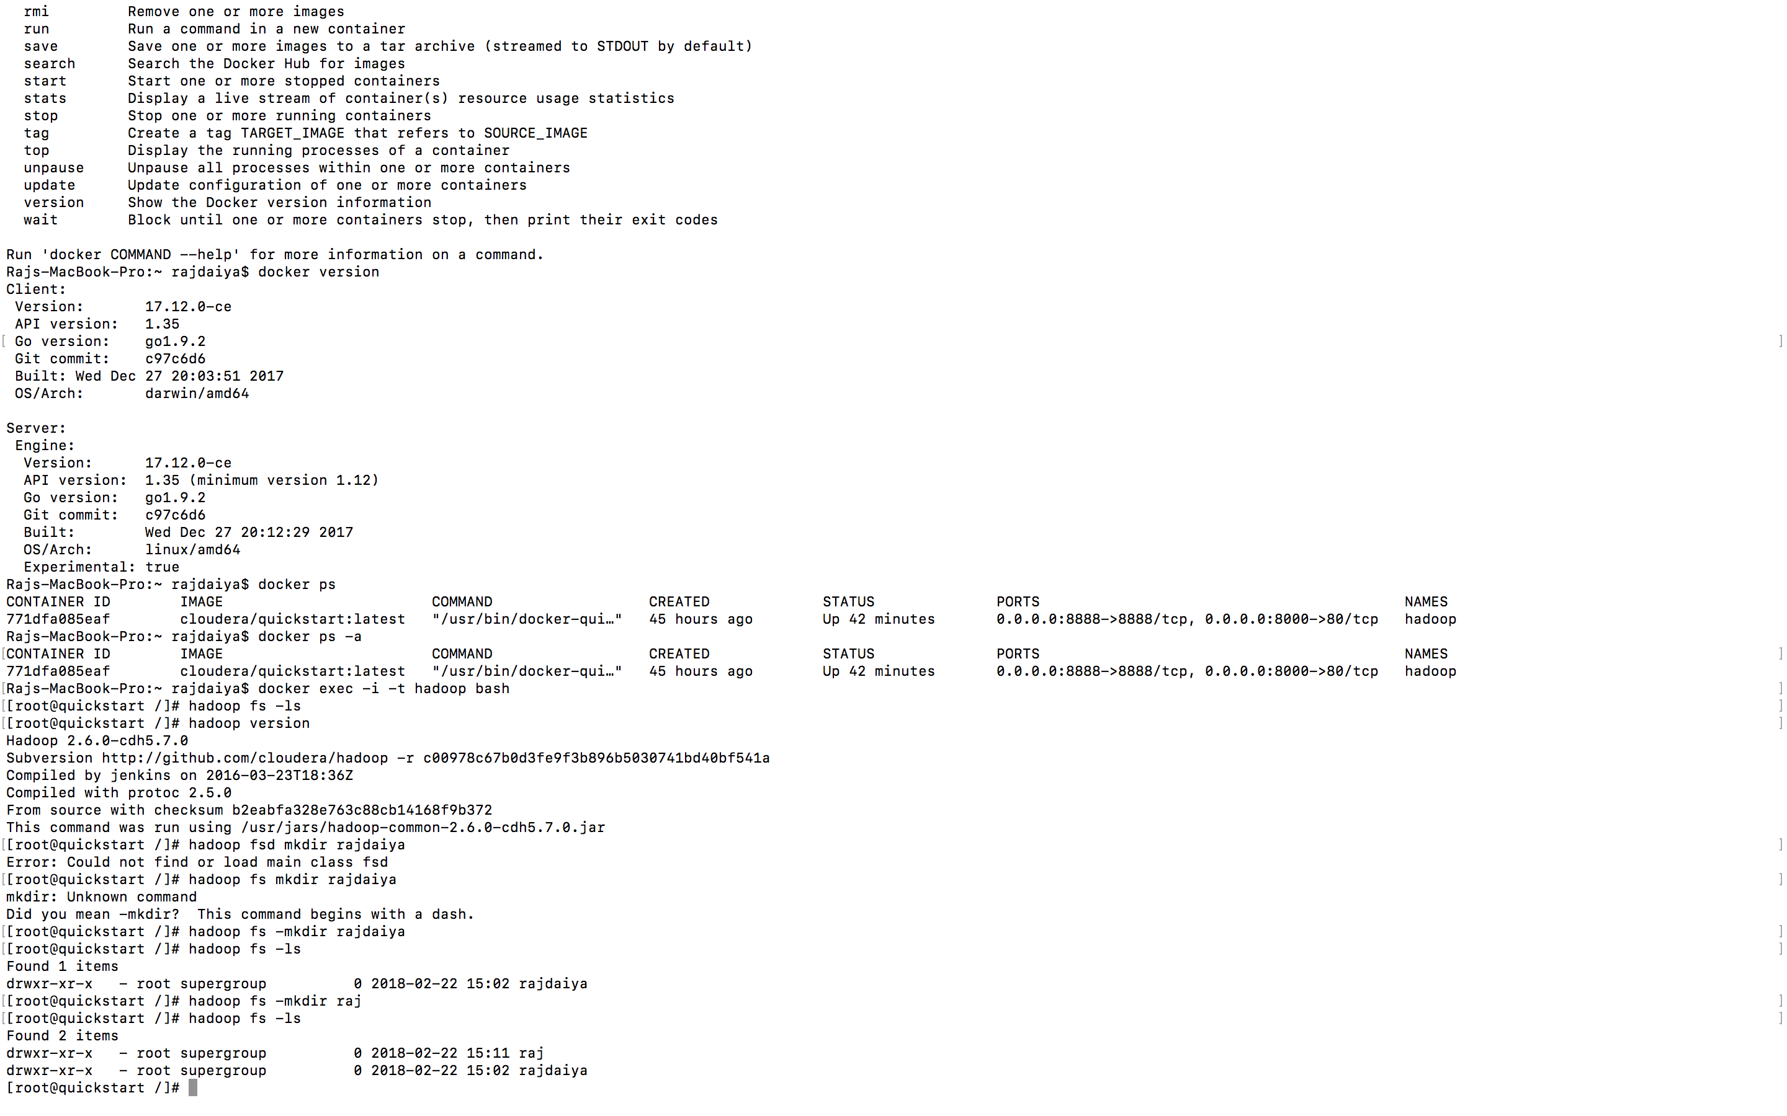

Hue login using cloudera



Users on Hue

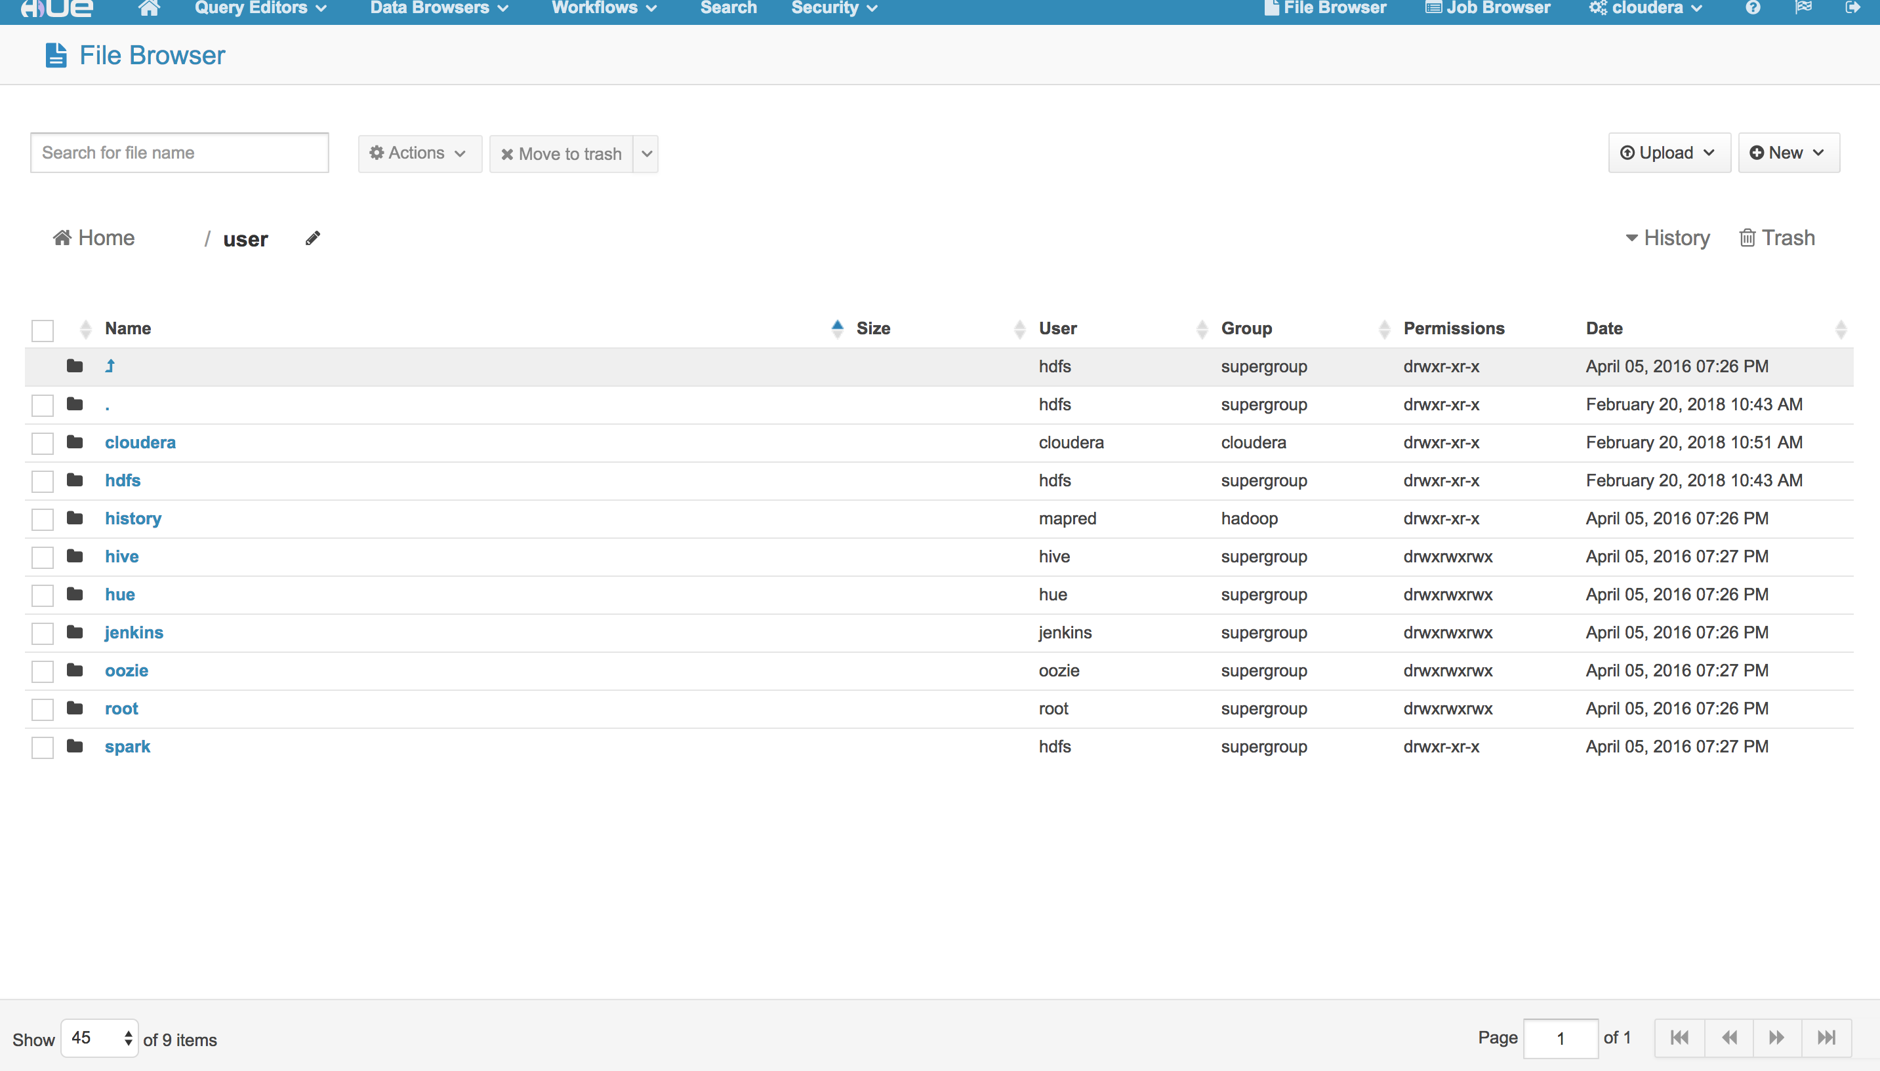

The mkdir command directories on Hue

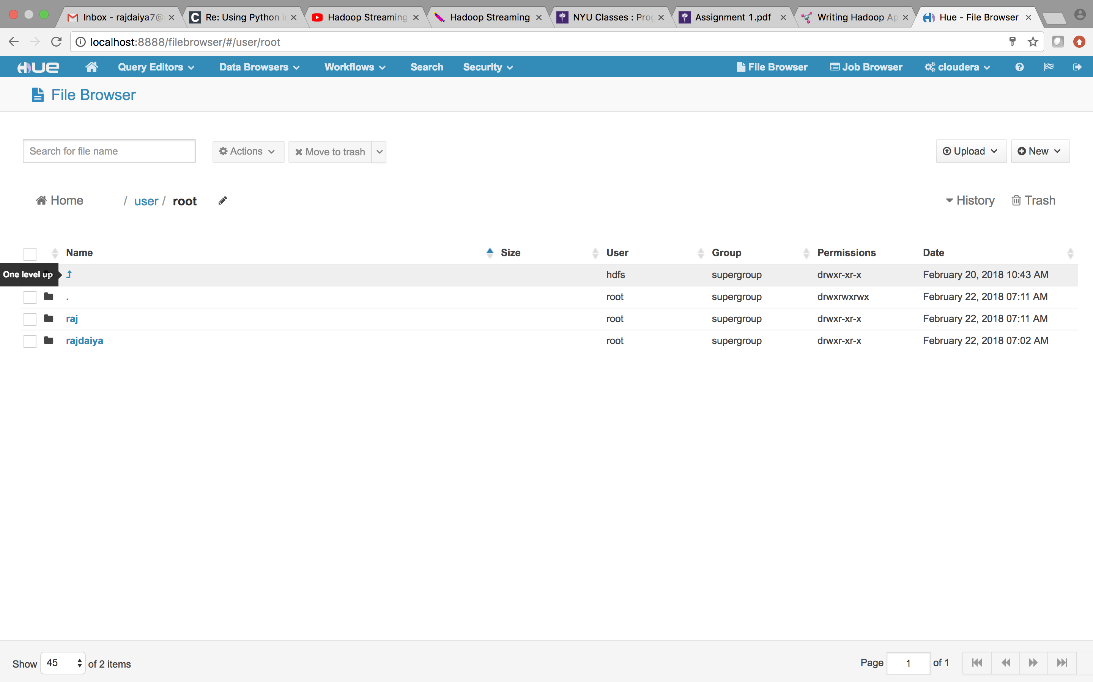

Submit a screen grab of your program running or completed in Hadoop. Hue has a jobs status page, use that one. Or use the command: ‘hadoop jar’:

* Running Hadoop using Hadoop-streaming:

